Mobile Oscilloscope

**CONCEPT: This project is a mini digital oscilloscope. This mobile oscilloscope allows users do the measuring anywhere they want. This oscilloscope is based on ATMEGA328 chip and built in A/D converter. Also, there is a LCD connects with the chip to display the wave of the signal and some values of it, such as frequency or Vpp.**

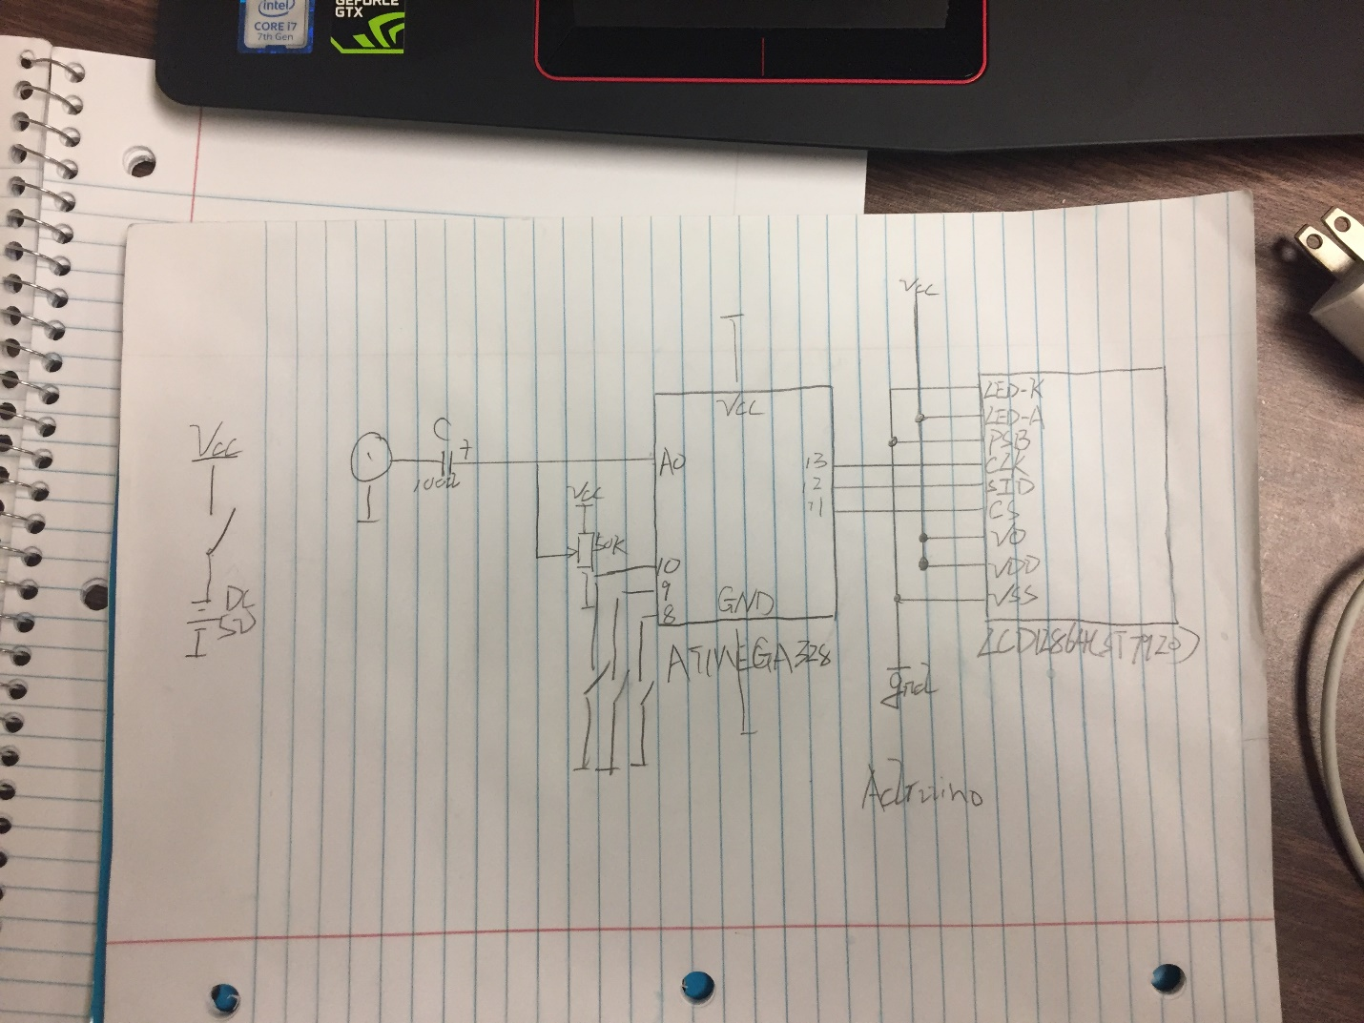

This schematic shows the input which could be an AC power or some circuit connects with the ATMEGA328 chip through a 100u capacitor. Also, there is a 50k potentiometer to adjust the signal wave to the center of the screen. Then there are three pins of this chip, one is to hold the wave and other two are increasing or decreasing the speed of the signal. Then there are three pins connects with LCD to display the signal wave and value of this signal.

For the programming, we are going to use the library of LCD which is called u8glib to control the LCD. Also, we will use the build-in function analogRead() to read the value from the part that we want to measure and give the value to the chip.

Components:

Atmega328-au

LCD12864(ST7920)

Capacitor(100u,25V)(0.1u)os

Potentiometer(50K)

Switches(3)

Battery Holder

Oscillator